**Phone Directory System**

**Description:**

The phone directory system allows the user to add new contacts, display all the contacts in the directory and search for the contact at any time using the name of the contact.

**Introduction:**

* The phone directory system is an effective way to store and organize contacts. It also enables the user to search for a particular contact from the long list of contacts by just its name.
* The data structure used in the phone directory system is “TREE” data structure which is an effective data structure for several reasons which are:
* Prefix search Efficiency
* Space efficiency
* Fast lookup
* Insertion and Deletion Efficiency

**Data Structure Functions:**

1. **ContactNode Constructor**: Initializes a ContactNode object with default values.
2. **Directory Constructor**: Initializes a Directory object with a root ContactNode.
3. **addContact**: Adds a new contact to the directory with associated details (phone number, email, birth date, and home address).
4. **findContact**: Searches for a contact by name and returns their phone number if found, otherwise an empty string.
5. **displayContactsInfo**: Recursively displays information for each contact starting from a given node (used internally for displaying all contacts).
6. **displayContacts**: Displays all contacts in the directory.
7. **main**: Implements a menu-driven interface to interact with the contact directory system, allowing users to add, display, find contacts, or quit the program.

**Test Cases:**

**Main Menu:-**

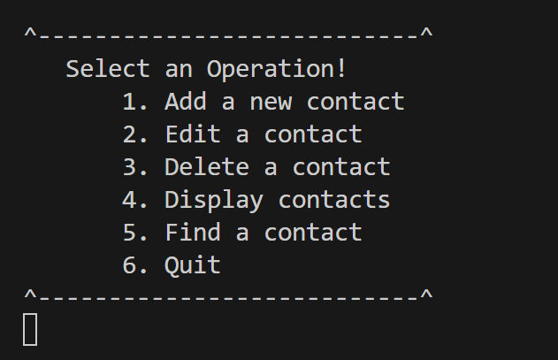

**Adding New Contact:**

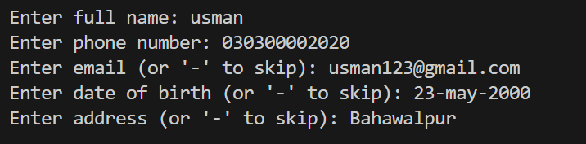

**Edit existing contact:-**

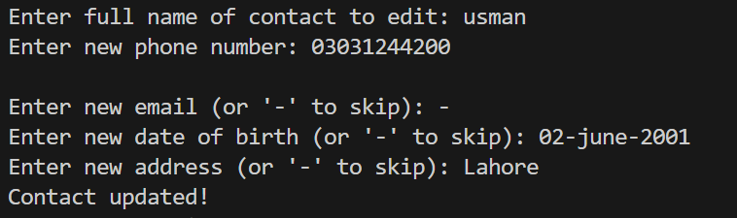

**Display All Contacts:-**

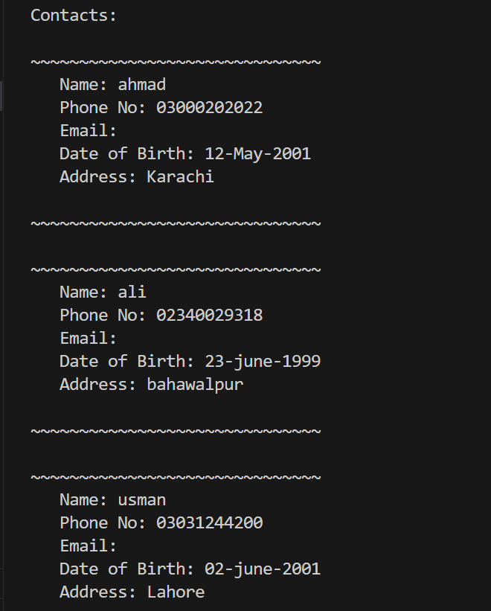

**Finding Contact:-**

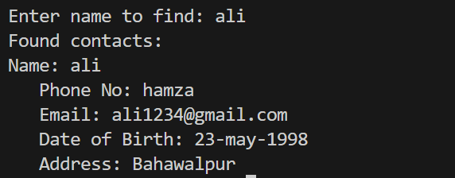

**Deleting a Contact:-**



**GitHub link:** [**https://github.com/na33mkh4an/DSA-projects**](https://github.com/na33mkh4an/DSA-projects)